AmirAbbas MoumeniZadeh – SID:810101529 – CA1 Report – Digital System ECE 894

1. 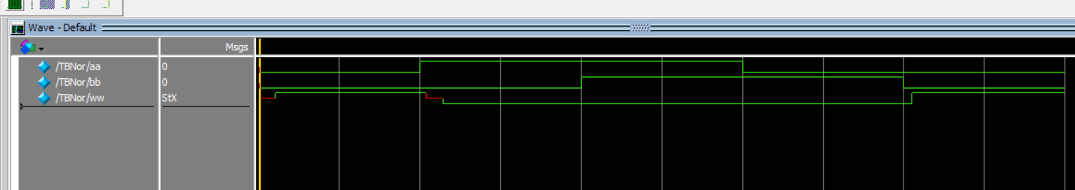2-Input Nor Implimentation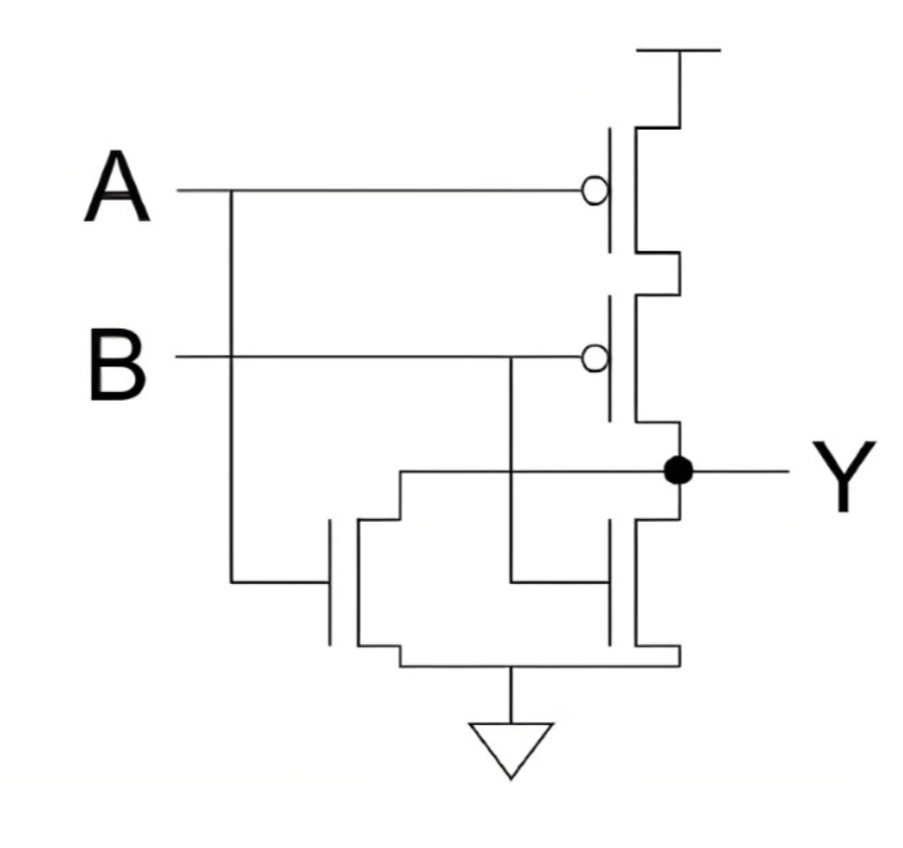

According to Calculation, worst-case dalay of this Circuit is 10ns, Which can be shown in the waveform diagram.

Calculation : pMOS Delay: (5,6,7) , nMOS Delay: (3,4,5)

Testbench Code :

*`timescale 1ns/1ns*

*module TBNor();*

*reg aa,bb;*

*wire ww;*

*mynor UUT(.a(aa),.b(bb),.w(ww));*

*initial begin*

*aa=0; bb=0;*

*#100 aa=1 ; bb=0;*

*#100 aa=1 ; bb=1;*

*#100 aa=0 ; bb=1;*

*#100 aa=0 ; bb=0;*

*#100 $stop;*

*end*

*endmodule*

Implimentation Code :

*`timescale 1ns/1ns*

*module mynor(input a,b , output w);*

*wire j;*

*supply0 gnd;*

*supply1 vdd;*

*pmos #(5,6,7)(j,vdd,a);*

*pmos #(5,6,7)(w,j,b);*

*nmos #(3,4,5)(w,gnd,a);*

*nmos #(3,4,5)(w,gnd,b);*

*endmodule*

1. 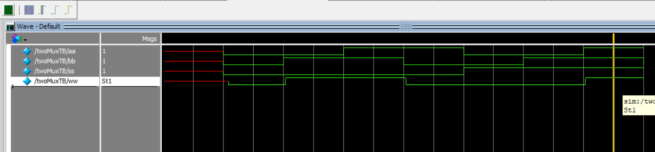2-to-1 Mux implimentation:

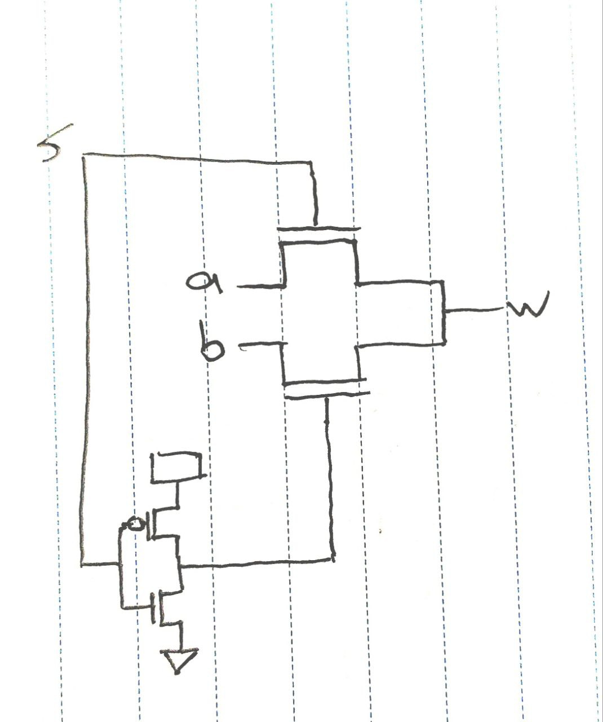

We can see through the waveform that in first half of wave form which *S* is 0, output just looks at *a* and follows it and in the second half the opposite. Which means when *S* is 1, output follows *b*.

*`timescale 1ns/1ns*

*module twoMuxTB();*

*reg aa,bb,ss;*

*wire ww;*

*twoOneMUX UUT1(.a(aa),.b(bb),.s(ss),.w(ww));*

*initial begin*

*#100 ss=0; aa=0; bb=0;*

*#100 ss=0; aa=0; bb=1;*

*#100 ss=0; aa=1; bb=1;*

*#100 ss=0; aa=1; bb=0;*

*#100 ss=1; aa=0; bb=0;*

*#100 ss=1; aa=0; bb=1;*

*#100 ss=1; aa=1; bb=1;*

*#100 ss=1; aa=1; bb=0;*

*end*

*endmodule*

*`timescale 1ns/1ns­*

*`timescale 1ns/1ns*

*module twoOneMUX(input a,b,s , output w);*

*wire j;*

*supply0 gnd;*

*supply1 vdd;*

*nmos #(3,4,5)(w,a,s);*

*pmos #(5,6,7)(j,vdd,s);*

*nmos #(3,4,5)(j,gnd,s);*

*nmos #(3,4,5)(w,b,j);*

*endmodule*

*module twoOneMUX(input a,b,s , output w);*

*wire j;*

*supply0 gnd;*

*supply1 vdd;*

*nmos #(3,4,5)(w,a,s);*

*pmos #(5,6,7)(j,vdd,s);*

*nmos #(3,4,5)(j,gnd,s);*

*nmos #(3,4,5)(w,b,j);*

*endmodule*

1. 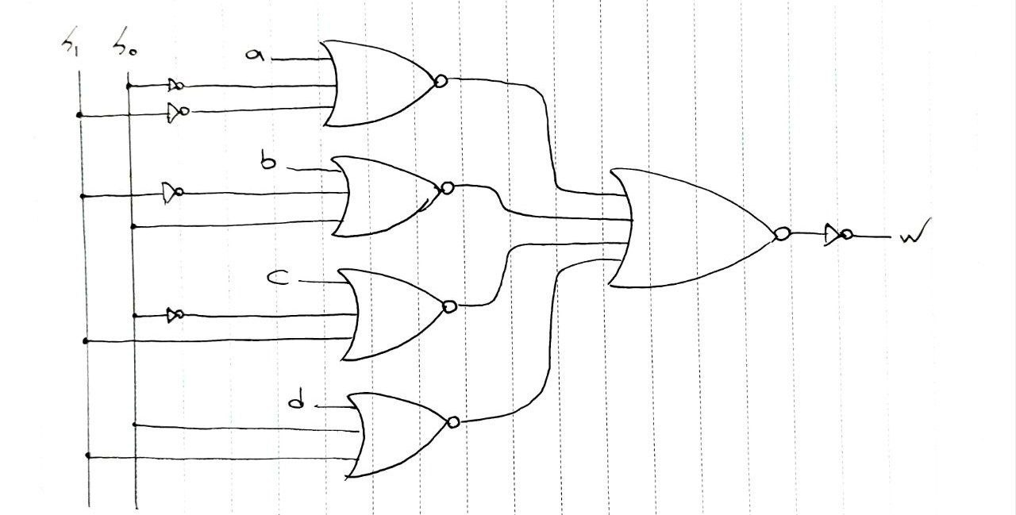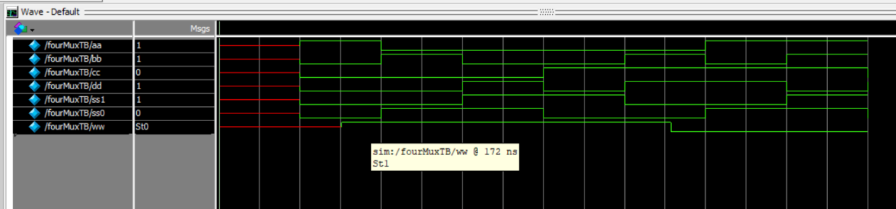­4-to-1 Mux

we can see through waveform that s1 and s0 are controling the output. When we have 00 on control we see *a* on output. 01 for *b*, 10 for *c* and 11 for *d*. ( the testbench is made in a situation that in every step the value that we expect to have it on output is different from the others so easily can be undrestood that circuit Is working correct or not).

*`timescale 1ns/1ns*

*module fourMuxTB();*

*reg aa,bb,cc,dd,ss1,ss0;*

*wire ww;*

*fourOneMUX UUT1(.a(aa),.b(bb),.c(cc),.d(dd),.s1(ss1),.s0(ss0),.w(ww));*

*initial begin*

*#100 ss1=0; ss0=0; aa=1; bb=0; cc=0; dd=0;*

*#100 ss1=0; ss0=1; aa=0; bb=1; cc=0; dd=0;*

*#100 ss1=1; ss0=1; aa=0; bb=0; cc=0; dd=1;*

*#100 ss1=1; ss0=0; aa=0; bb=0; cc=1; dd=0;*

*#100 ss1=0; ss0=0; aa=0; bb=1; cc=1; dd=1;*

*#100 ss1=0; ss0=1; aa=1; bb=0; cc=1; dd=1;*

*#100 ss1=1; ss0=1; aa=1; bb=1; cc=1; dd=0;*

*#100 ss1=1; ss0=0; aa=1; bb=1; cc=0; dd=1;*

*end*

*endmodule*

*`timescale 1ns/1ns*

*module fourOneMUX(input a,b,c,d,s1,s0 , output w);*

*wire i,j,k,l,p;*

*nor #(15,21)(i,~s1,~s0,a);*

*nor #(15,21)(j,~s1,s0,b);*

*nor #(15,21)(k,s1,~s0,c);*

*nor #(15,21)(l,s1,s0,d);*

*nor #(20,28)(p,i,j,k,l);*

*nor #(10,14)(w,p,p);*

*endmodule*

Which makes sence bacause we have a 3-input and a four input Nor and two invertors which have been made by conecting Nors inputs together SO we expect to have a lot of Timing delay

1. 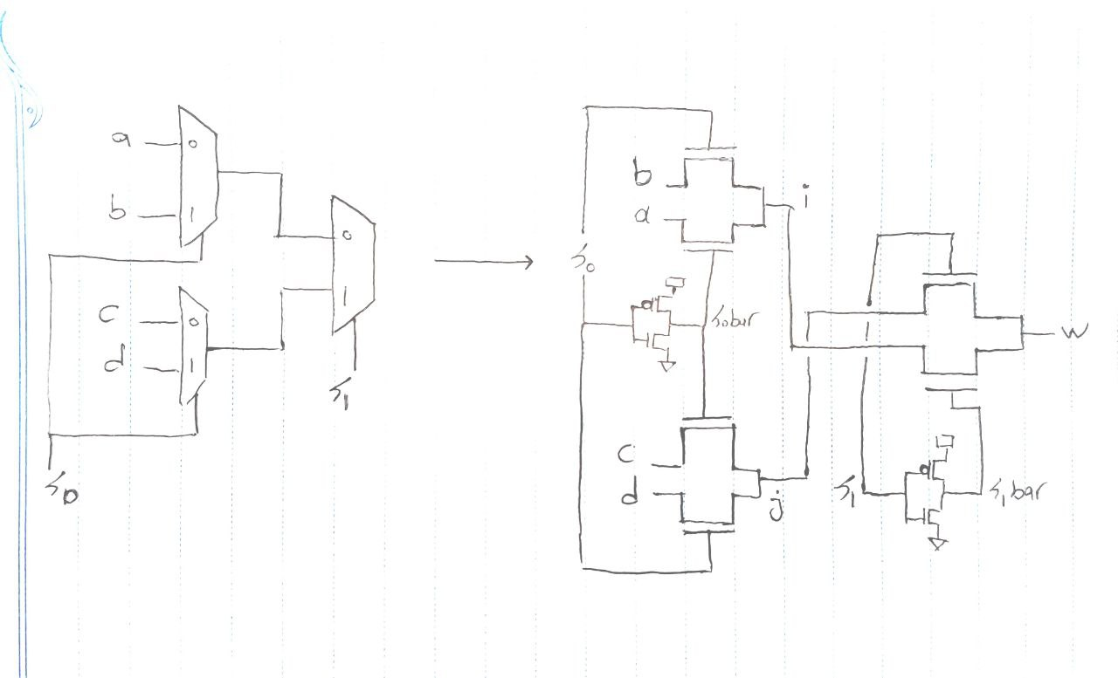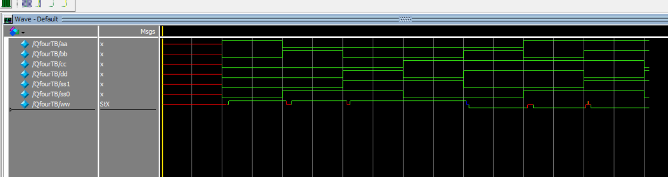4-to-1 Mux Implimenting with 2-to-1 Mux

Test bench is just like the previous question. we can see through waveform that s1 and s0 are controling the output. When we have *00* on control we see *a* on output. *01* for *b*, 10 for *c* and *11* for *d*.

We can see that there is a lot of glitch on output comparing to the previous question but the timing delay is lower than previous one. We can examine this in next question in next question more accurate with seeing both outputs together.

*`timescale 1ns/1ns*

*module QuesFourMUX(input a,b,c,d,s1,s0 , output w);*

*wire i,j,s0bar , s1bar;*

*supply0 gnd;*

*supply1 vdd;*

*//Mux1 a,b*

*nmos #(3,4,5)(i,b,s0);*

*nmos #(3,4,5)(i,a,s0bar);*

*//s0 inverter*

*nmos #(3,4,5)(s0bar,gnd,s0);*

*pmos #(5,6,7)(s0bar,vdd,s0);*

*//Mux2 c,d*

*nmos #(3,4,5)(j,c,s0bar);*

*nmos #(3,4,5)(j,d,s0);*

*//Mux3*

*nmos #(3,4,5)(w,j,s1);*

*nmos #(3,4,5)(w,i,s1bar);*

*//s1 inverter*

*nmos #(3,4,5)(s1bar,gnd,s1);*

*pmos #(5,6,7)(s1bar,vdd,s1);*

*endmodule*

*`timescale 1ns/1ns*

*module fourMuxTB();*

*reg aa,bb,cc,dd,ss1,ss0;*

*wire ww;*

*fourOneMUX UUT1(.a(aa),.b(bb),.c(cc),.d(dd),.s1(ss1),.s0(ss0),.w(ww));*

*initial begin*

*#100 ss1=0; ss0=0; aa=1; bb=0; cc=0; dd=0;*

*#100 ss1=0; ss0=1; aa=0; bb=1; cc=0; dd=0;*

*#100 ss1=1; ss0=1; aa=0; bb=0; cc=0; dd=1;*

*#100 ss1=1; ss0=0; aa=0; bb=0; cc=1; dd=0;*

*#100 ss1=0; ss0=0; aa=0; bb=1; cc=1; dd=1;*

*#100 ss1=0; ss0=1; aa=1; bb=0; cc=1; dd=1;*

*#100 ss1=1; ss0=1; aa=1; bb=1; cc=1; dd=0;*

*#100 ss1=1; ss0=0; aa=1; bb=1; cc=0; dd=1;*

*end*

*endmodule*

1. 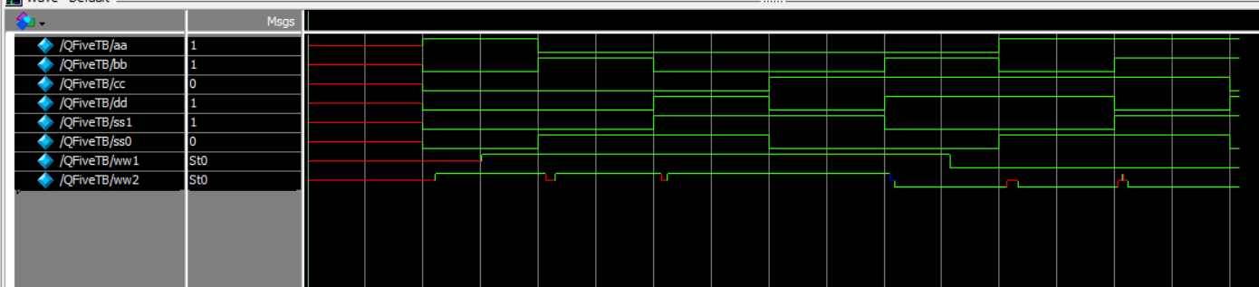Examine both 4-to-1 Muxes together

*ww1* is output for Mux made with Nor Gates and *ww2* is output for 4-1Mux made with 3 2-1 Muxes. As we can see delay for *ww1* is much more than *ww2* which is bacause in first circuit there are much more transistors in use ( but in second circuit this number is much lower (

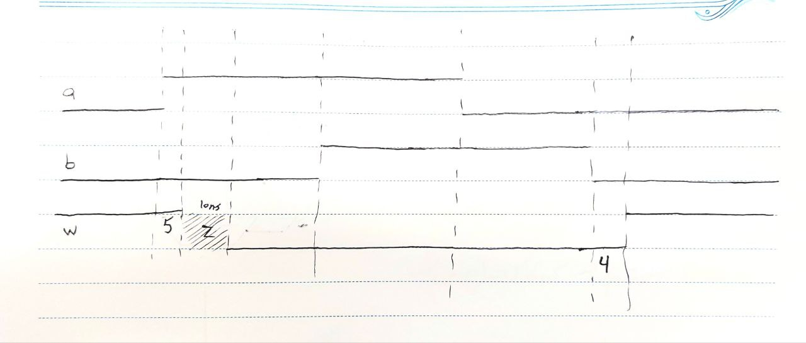Hand drawn waveform for Problem 1.